**NST31042 - Practical for Scaling and Connecting**

Department of Information & Communication Technology Faculty of Technology, SEUSL

SEU-IS-19-ICT-046

LABREPORT 3

**Title:** Revising DHCP Configuration

Aim:

1. Getting Familiar DHCP Server
2. automatically assign IP addresses and network configurations

**Task:**

1. Install DHCP Server
2. Define scope options
3. Verify client configuration

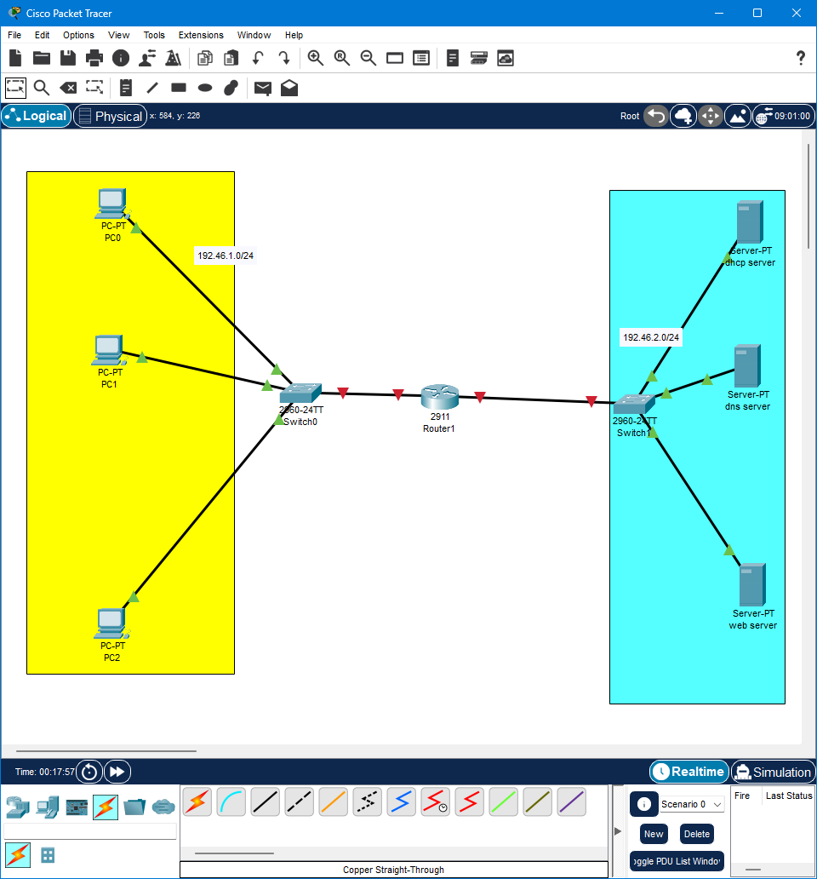

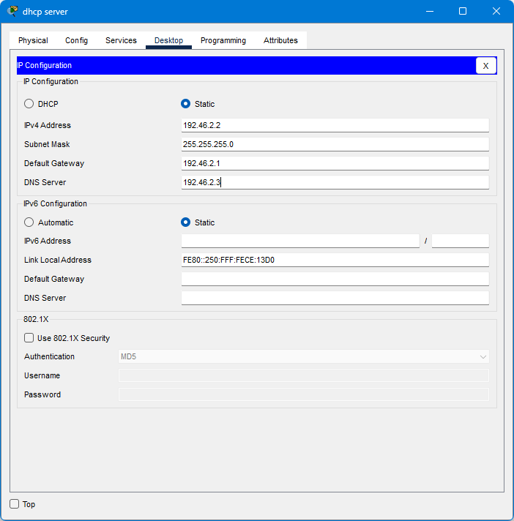

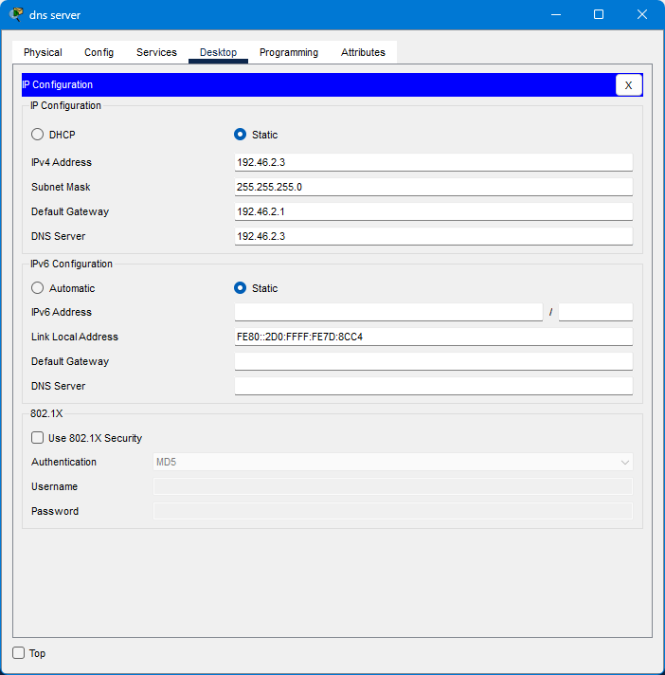

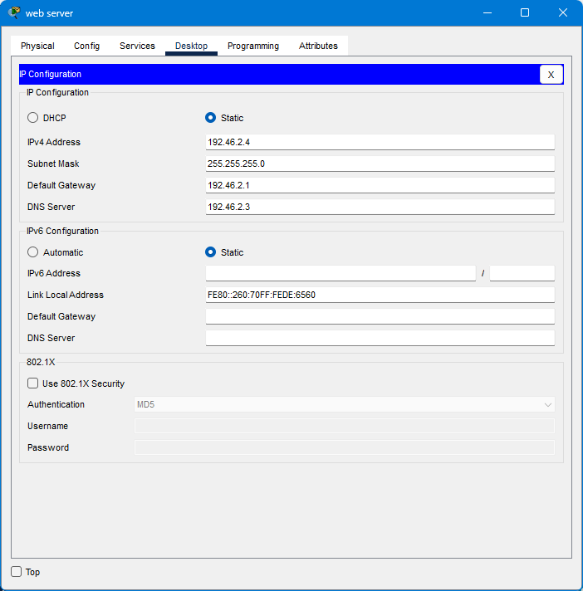

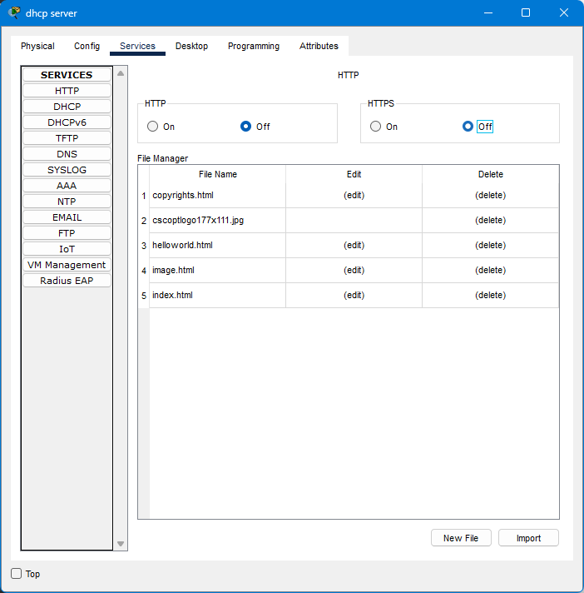

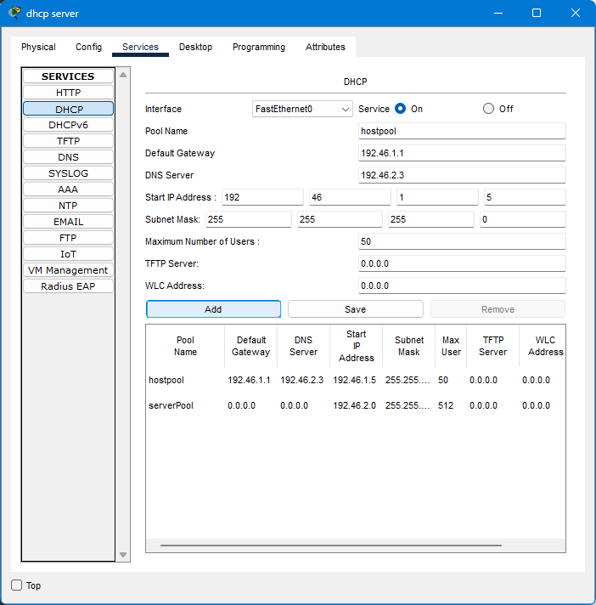

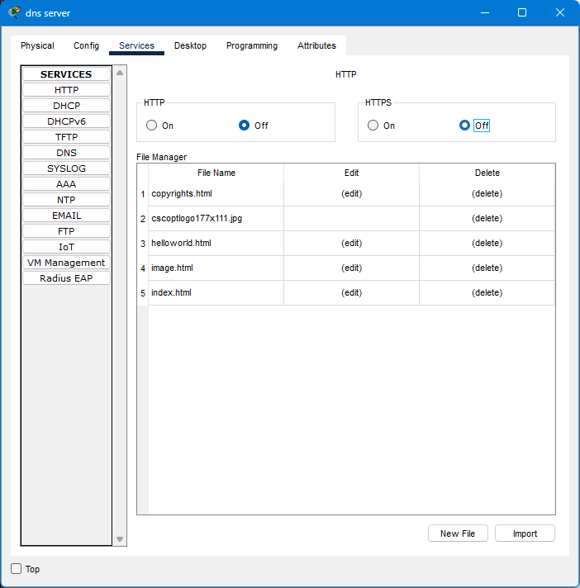

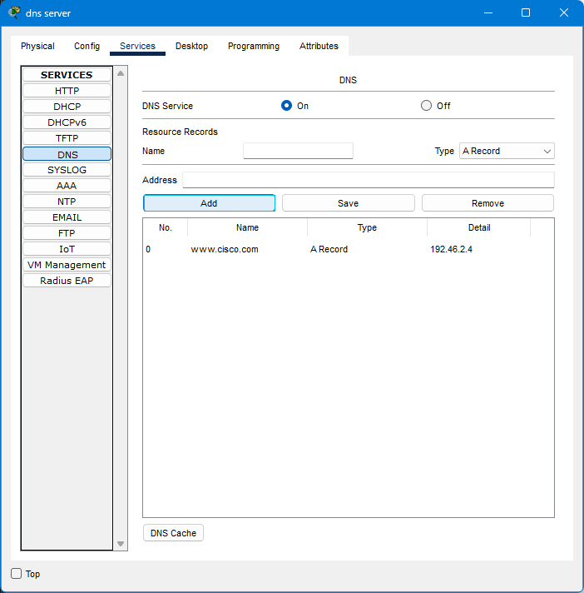

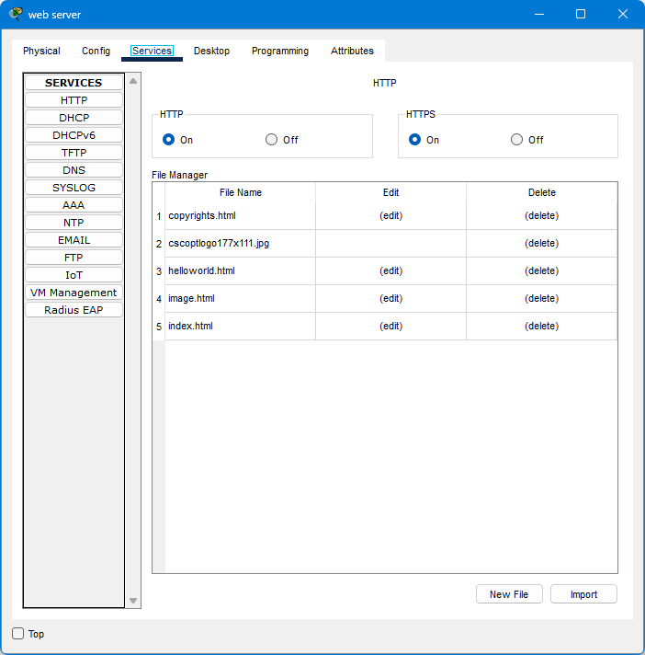

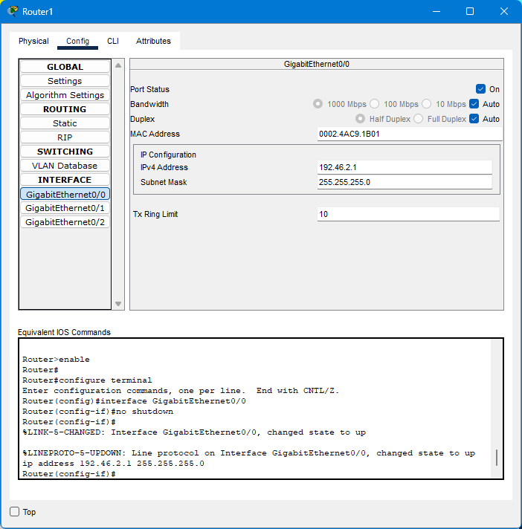

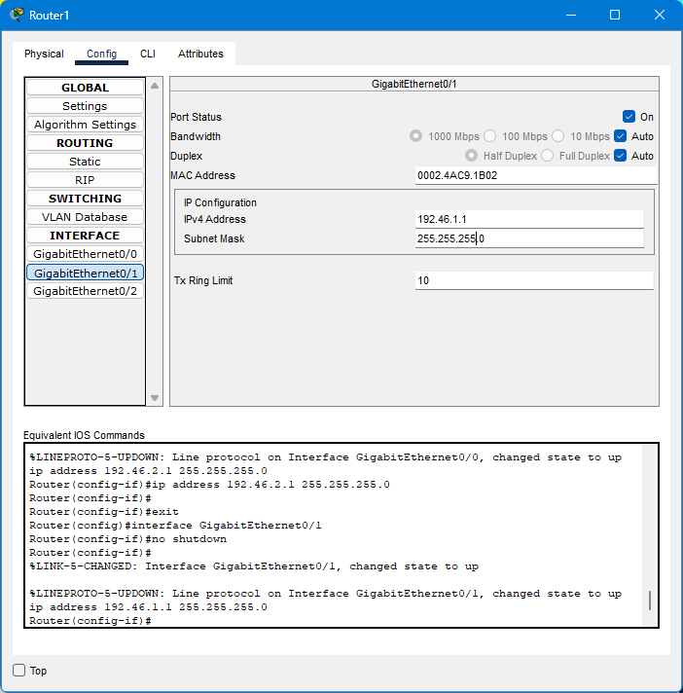

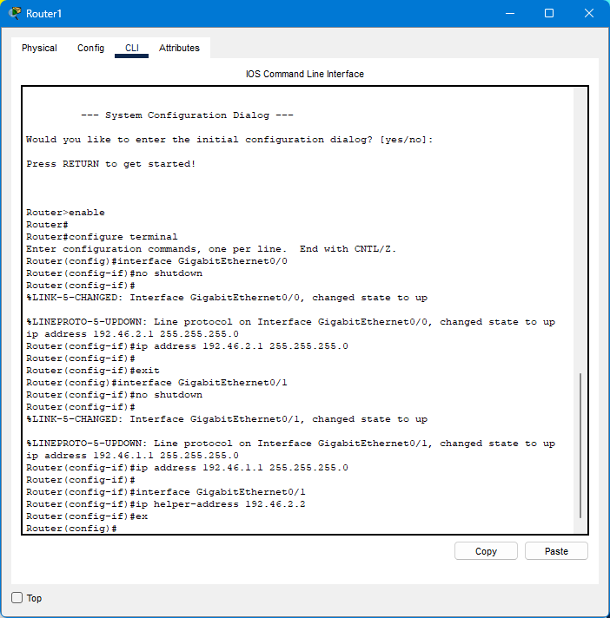

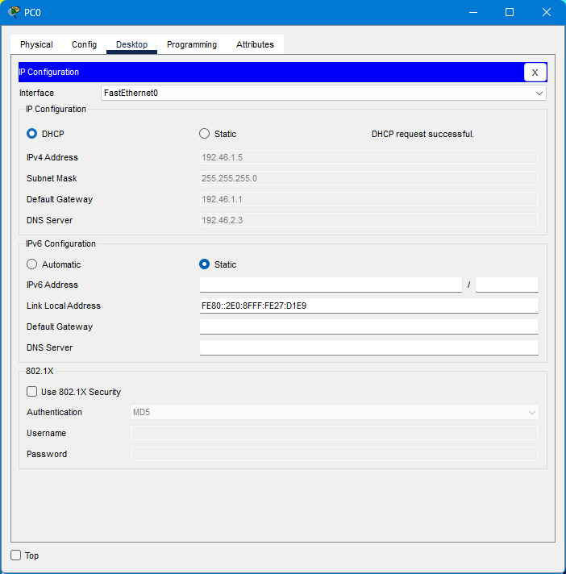

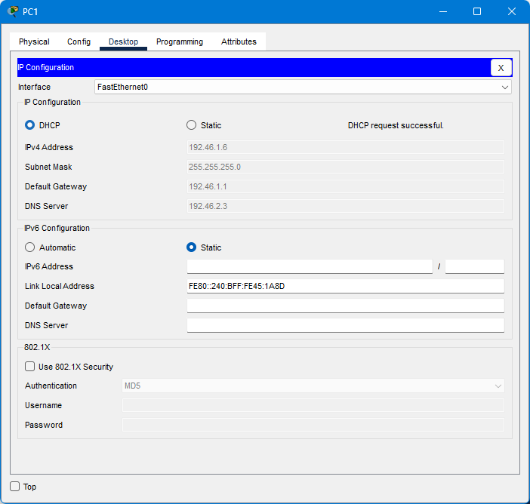

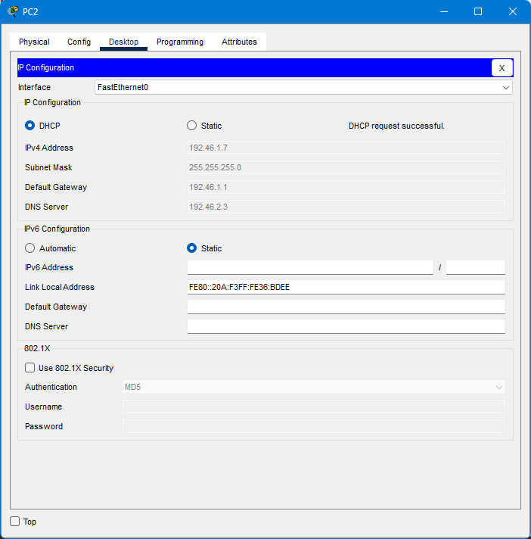

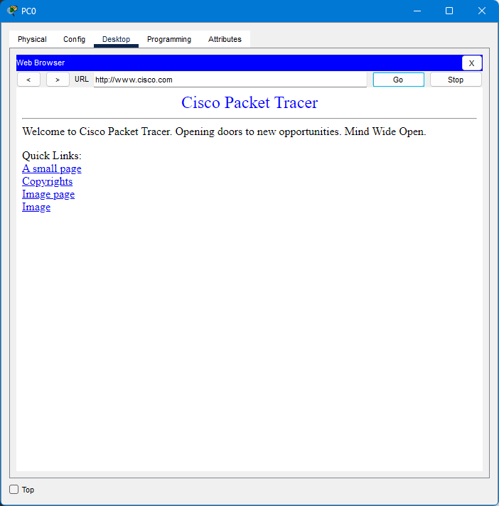

Q2

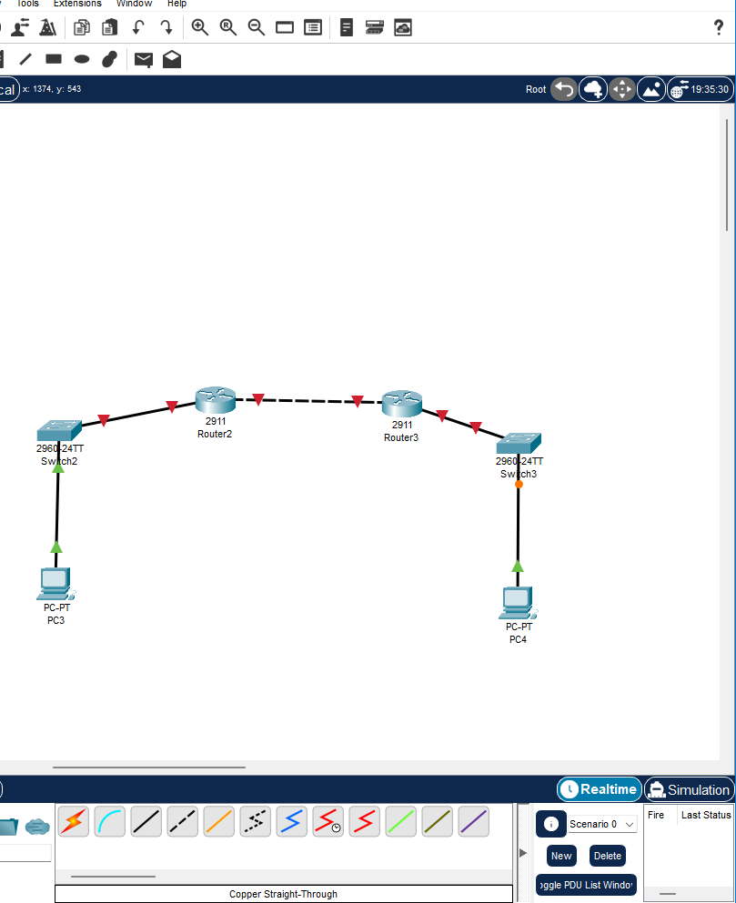

Configure the following DHCP pools on R2:

POOL1: 192.xxx.1.0/24 (reserve .1 to .10)

DNS 8.8.8.8

Domain: www.cisco.com

Default Gateway: R1

POOL2: 192.xxx.2.0/24 (reserve .1 to .10)

DNS 8.8.8.8

Domain: www.cisco.com

Default Gateway: R2

POOL3: 203.xxx.113.0/30 (reserve .1)

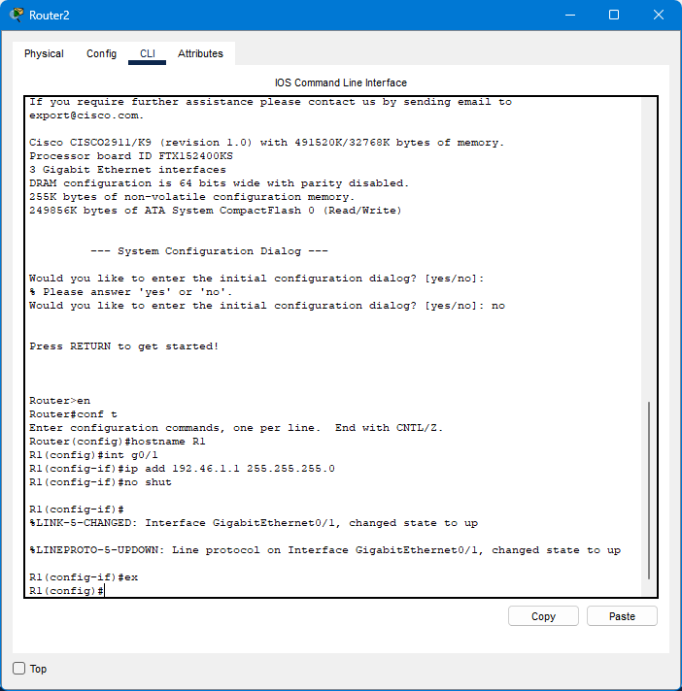

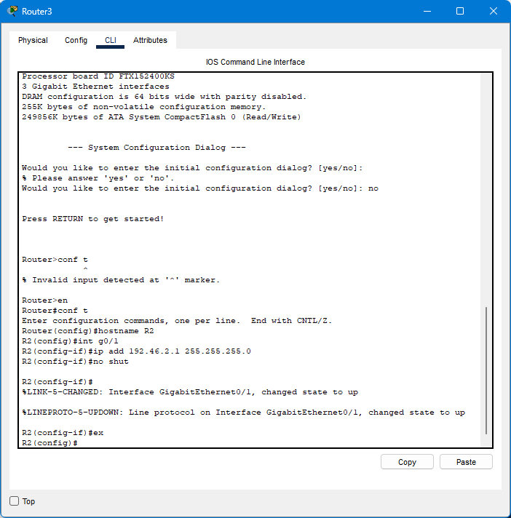

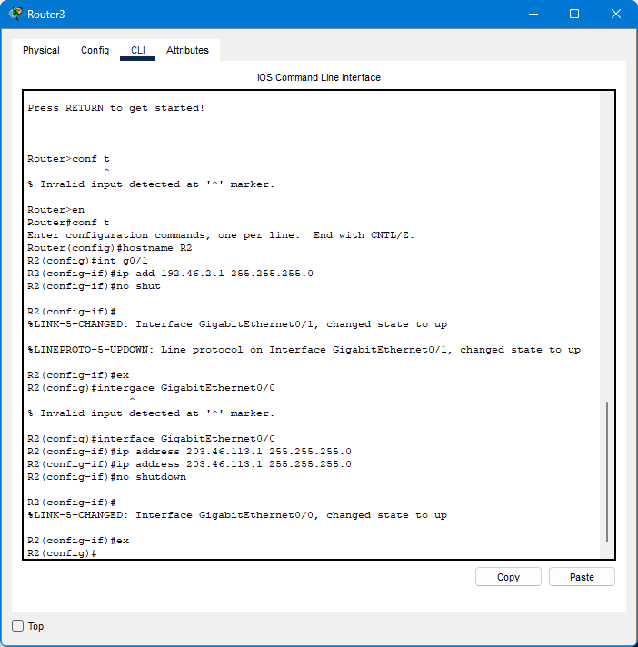

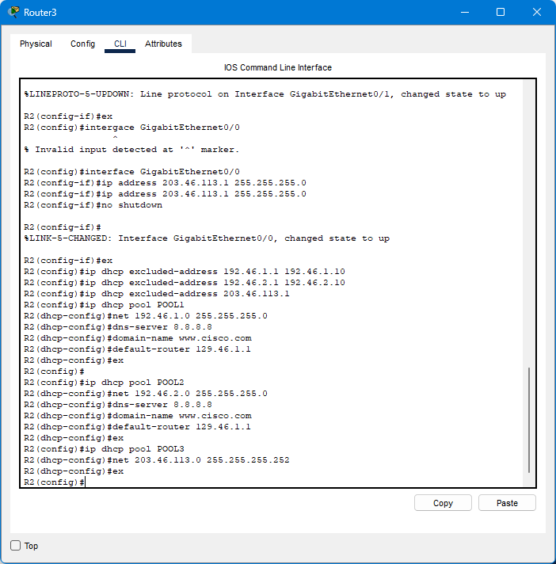

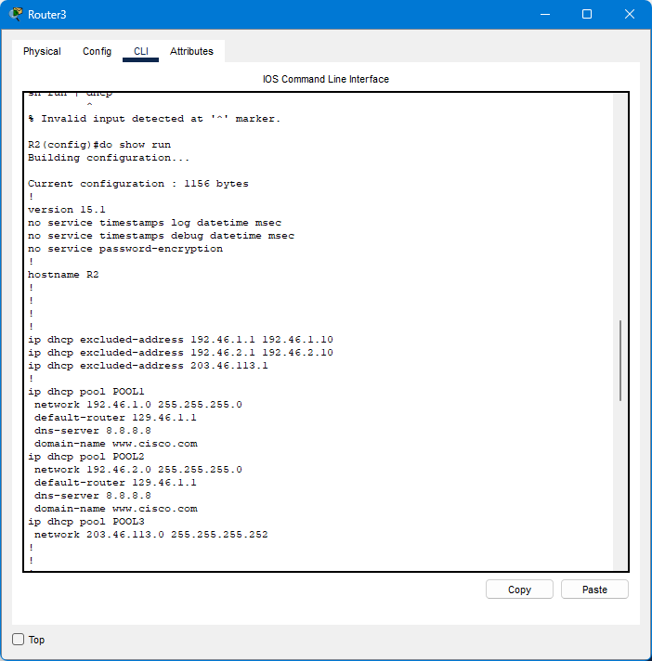

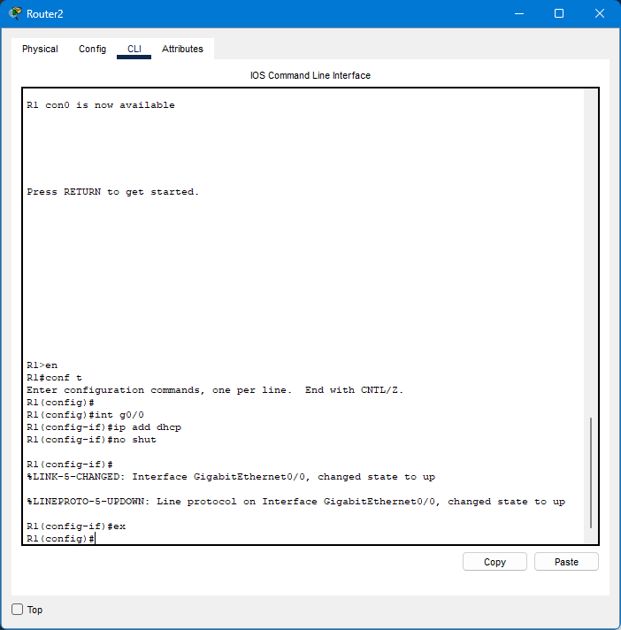

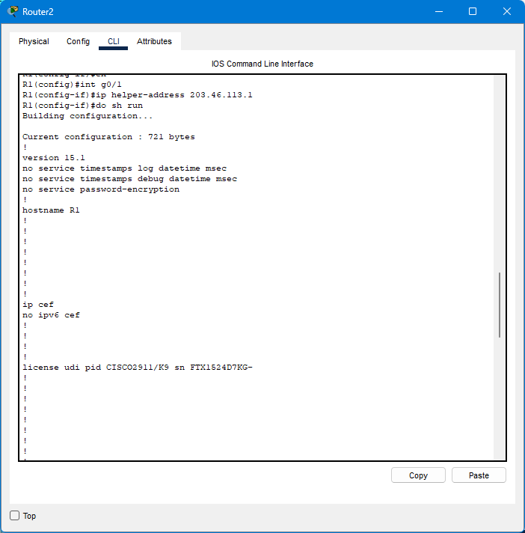

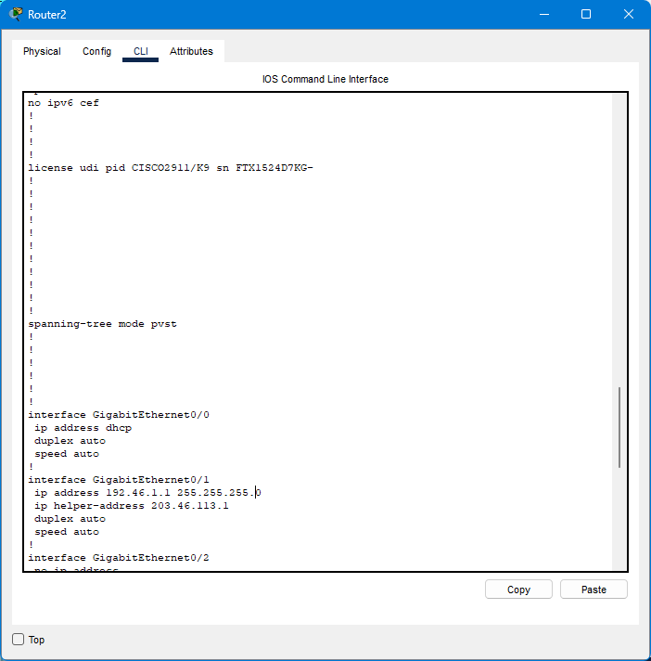

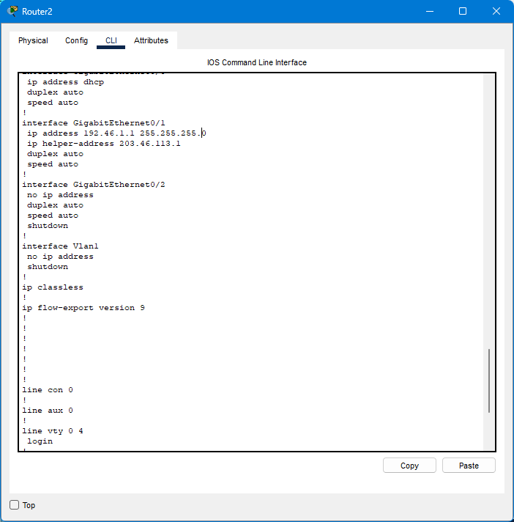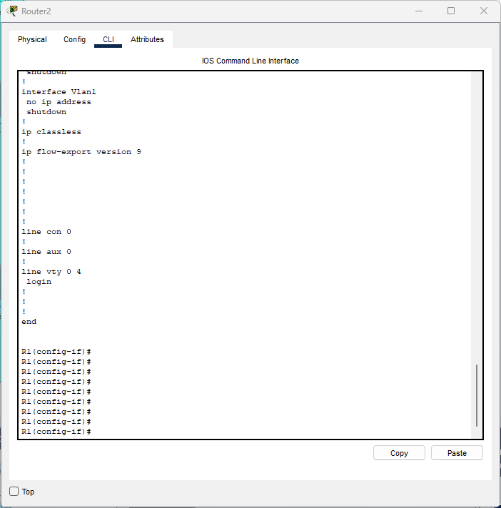

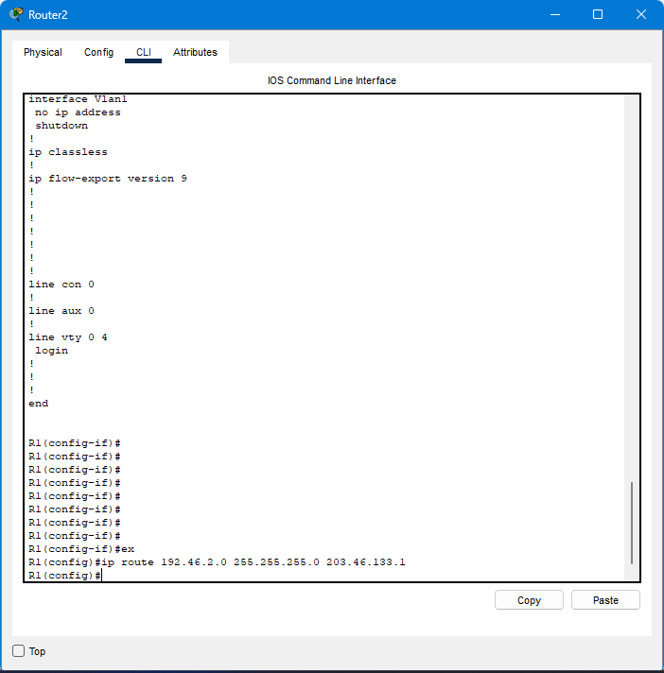

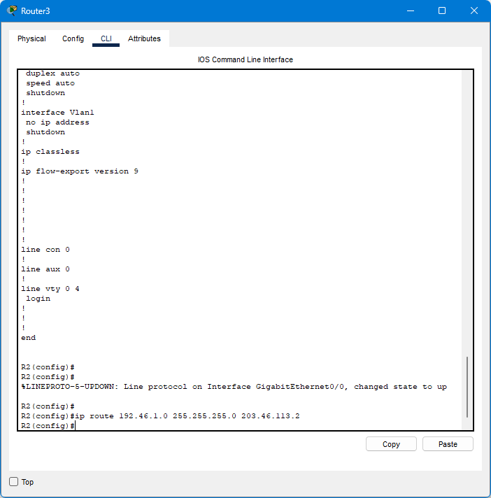

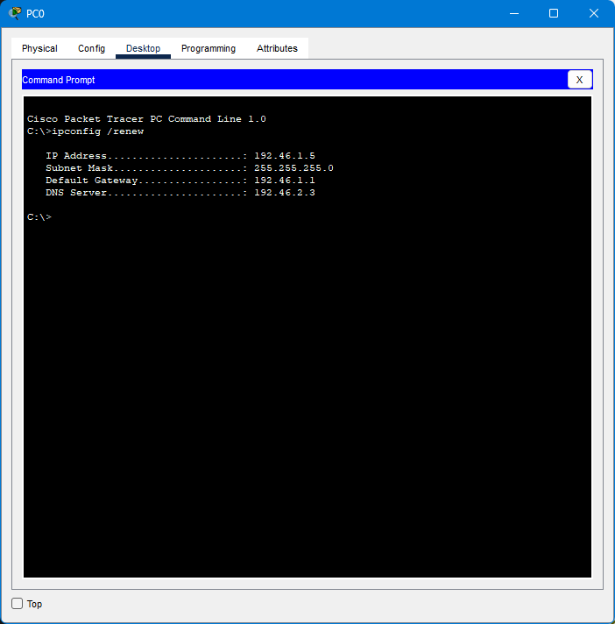

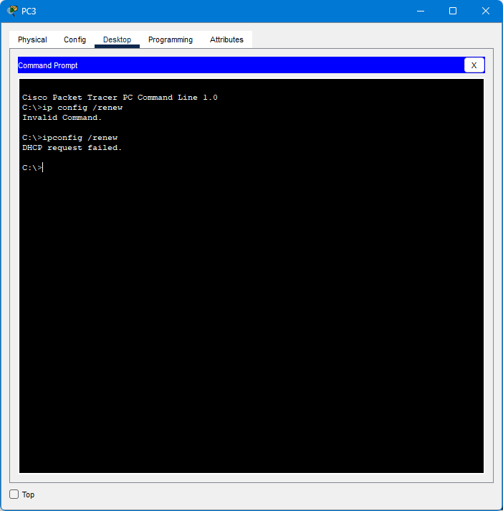

Discussion:

* from this session I have learnt that how to practice with dhcp server
* A DHCP Server is a network server that automatically provides and assigns IP addresses, default gateways and other network parameters to client devices. It relies on the standard protocol known as Dynamic Host Configuration Protocol or DHCP to respond to broadcast queries by clients.

References:

https://www.google.com/search?q=what+is+dhcp+server&oq=what+is+dhcp+se&gs_lcrp=EgZjaHJvbWUqBwgAEAAYgAQyBwgAEAAYgAQyBggBEEUYOTIHCAIQABiABDIHCAMQABiABDIHCAQQABiABDIHCAUQABiABDIHCAYQABiABDIHCAcQABiABDIHCAgQABiABDIHCAkQABiABKgCCLACAQ&sourceid=chrome&ie=UTF-8